AGSUP_ENDURANCE
Description:
Execute performance tests using YAML file (scripts not set using throughput timer)
Directory: [loadtestwt1/loadtestwt2] /home/devops/agsup-endurance
To obtain artifacts in the execution, add the following to the docker section of the pipeline:
-v /home/devops/agsup-endurance/artifacts/${build_number}:/tmp/artifacts \

Jenkins Job link: http://jenkinsqant1:8080/view/Performance/job/AGSUP_ENDURANCE/

Build with Parameters
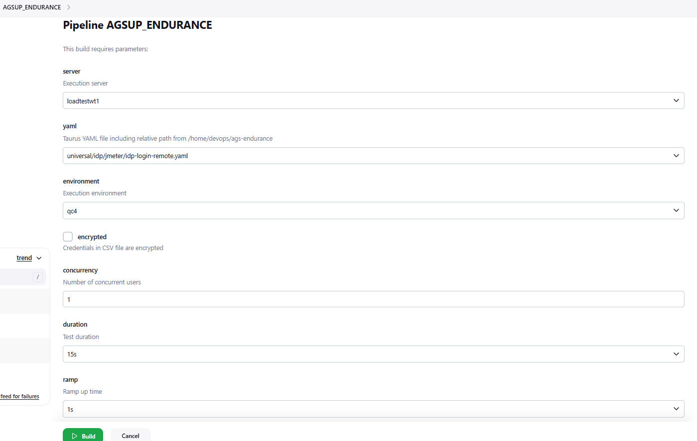

Config:
Description:
Execute performance tests using YAML file (scripts not set using throughput timer)
Directory: [loadtestwt1/loadtestwt2] /home/devops/agsup-endurance

To obtain artifacts in the execution, add the following to the docker section of the pipeline: -v /home/devops/agsup-endurance/artifacts/${build_number}:/tmp/artifacts \

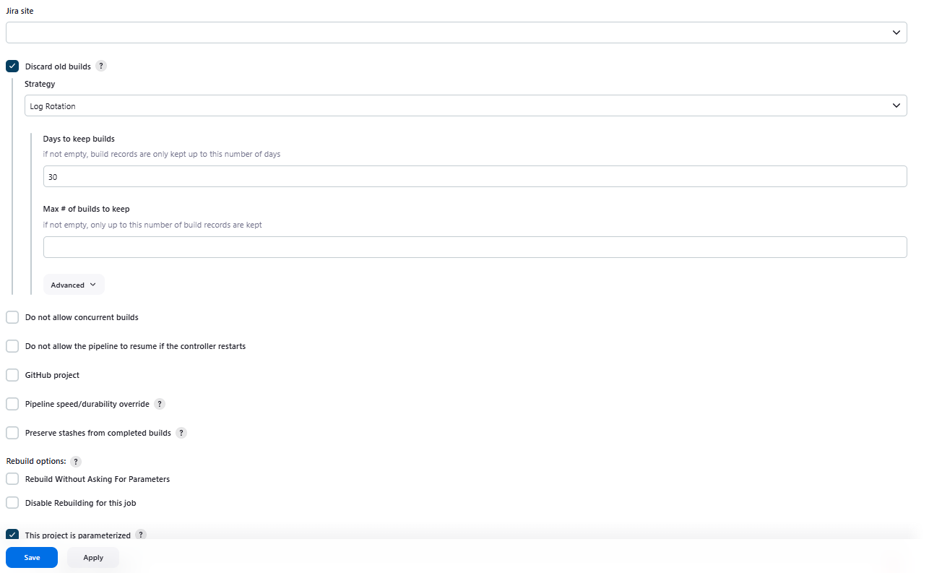
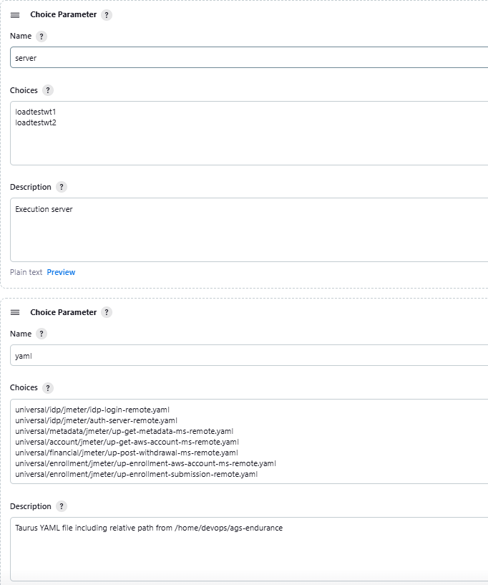
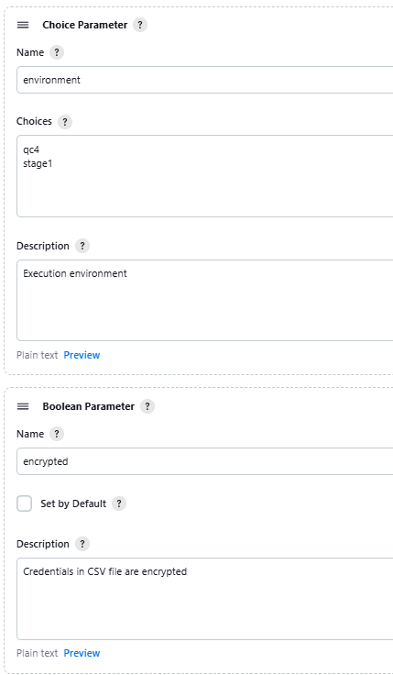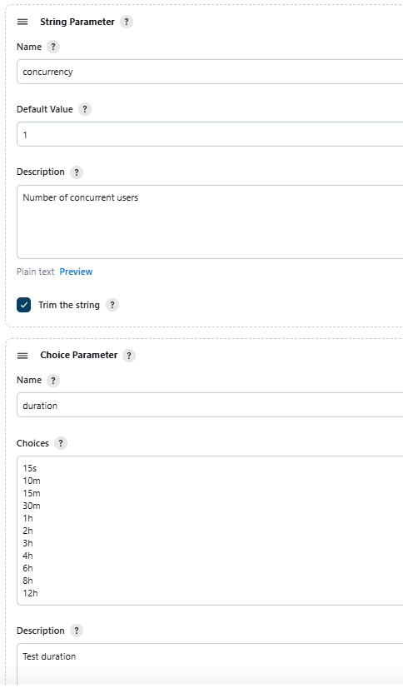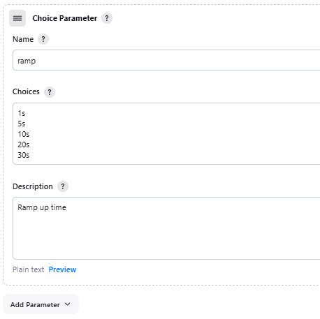

Pipeline:
stage("Run AGSUP Endurance Test on ${environment}")
{
node("${server}")
{
cmd1= "cd /home/devops/agsup-endurance"
docker_run="""docker run --rm --privileged \
-e PYTHONWARNINGS="ignore:Unverified HTTPS request" \
-e jmconcurrency="${concurrency}" \
-e jmhold="${duration}" \
-e jmramp="${ramp}" \
-e jencryption="${encrypted}" \
-v /home/devops/agsup-endurance:/bzt-configs \
--memory="4096m" \
--oom-kill-disable \
--cpu-period="100000" \
--cpu-quota="400000" \
--env-file "setup/${environment}.properties" \
blazemeter/taurus/withplugins:latest setup/base_taurus.yaml ${yaml}"""
catchError(buildResult: 'FAILURE', stageResult: 'FAILURE'){
def cmd ="${cmd1};${docker_run};"
steps.sh script: cmd;
}
}
}

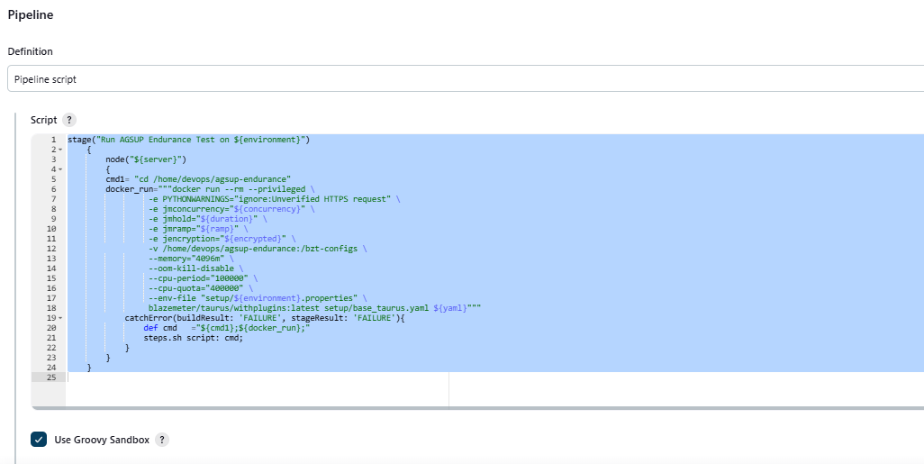

Job run Details:
http://jenkinsqant1:8080/view/Performance/job/AGSUP_ENDURANCE/666/
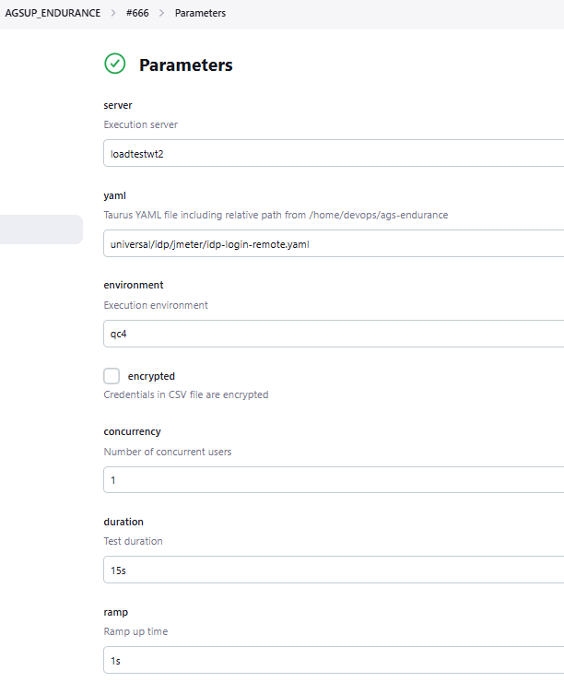
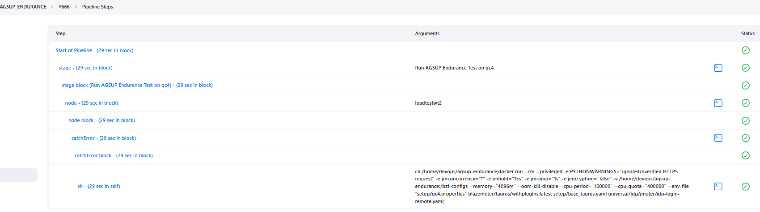

Console Output:
Started by user unknown or anonymous
[Pipeline] Start of Pipeline
[Pipeline] stage
[Pipeline] { (Run AGSUP Endurance Test on qc4)
[Pipeline] node
Running on loadtestwt2 in /home/devops/qajenkins/workspace/AGSUP_ENDURANCE
[Pipeline] {
[Pipeline] catchError
[Pipeline] {
[Pipeline] sh
+ cd /home/devops/agsup-endurance
+ docker run --rm --privileged -e 'PYTHONWARNINGS=ignore:Unverified HTTPS request' -e jmconcurrency=1 -e jmhold=15s -e jmramp=1s -e jencryption=false -v /home/devops/agsup-endurance:/bzt-configs --memory=4096m --oom-kill-disable --cpu-period=100000 --cpu-quota=400000 --env-file setup/qc4.properties blazemeter/taurus/withplugins:latest setup/base_taurus.yaml universal/idp/jmeter/idp-login-remote.yaml
13:39:42 INFO: Taurus CLI Tool v1.16.46
13:39:42 INFO: Starting with configs: ['/root/.bzt-rc', 'setup/base_taurus.yaml', 'universal/idp/jmeter/idp-login-remote.yaml']
13:39:42 INFO: Configuring...
13:39:42 INFO: Overriding proxy settings using taurus configuration
13:39:42 INFO: Using proxy 'http://webproxywt-vip.int.acs529.com:3128'
13:39:42 INFO: Artifacts dir: /tmp/artifacts
13:39:42 INFO: Preparing...
13:39:42 WARNING: Failed to check for updates
13:39:42 INFO: Using Cgroups1LocalMonitor for engine health monitoring
13:39:42 WARNING: Guessed location from search paths for idp-login.jmx: /bzt-configs/universal/idp/jmeter/idp-login.jmx
13:39:43 INFO: 1 obsolete CookieManagers are found and fixed
13:39:47 INFO: Sending of engine metrics to happysocks is disabled. modules.blazemeter.happysocks-address setting was not provided
13:39:47 INFO: Starting...
13:39:47 INFO: Waiting for results...
13:39:47 INFO: Initiating data feeding...
13:39:48 INFO: Started data feeding: https://a.blazemeter.com/app/#/masters/81409975
13:39:49 INFO: Public report link: https://a.blazemeter.com/app/?public-token=Q4p8uQg8ectuDbwk9JYXIOeKkjeQiqxZqRVMuW0sk2tYe298go#/masters/81409975/summary
13:39:56 INFO: Changed data analysis delay to 4s
13:40:00 INFO: Current: 1 vu 4 succ 0 fail 0.586 avg rt / Cumulative: 0.391 avg rt, 0% failures
13:40:01 INFO: Changed data analysis delay to 2s
13:40:01 INFO: Current: 1 vu 6 succ 0 fail 0.311 avg rt / Cumulative: 0.264 avg rt, 4% failures
13:40:02 INFO: Changed data analysis delay to 3s
13:40:02 INFO: Current: 1 vu 5 succ 0 fail 0.374 avg rt / Cumulative: 0.260 avg rt, 3% failures
13:40:04 INFO: Current: 1 vu 3 succ 0 fail 0.036 avg rt / Cumulative: 0.239 avg rt, 3% failures
13:40:06 INFO: Changed data analysis delay to 2s
13:40:06 INFO: Current: 1 vu 7 succ 0 fail 0.276 avg rt / Cumulative: 0.258 avg rt, 2% failures
13:40:09 WARNING: Please wait for graceful shutdown...
13:40:09 INFO: Shutting down...
13:40:09 INFO: Post-processing...
13:40:09 INFO: Test duration: 0:00:22
13:40:09 INFO: Samples count: 60, 1.67% failures
13:40:09 INFO: Average times: total 0.241, latency 0.090, connect 0.001
13:40:09 INFO: Percentiles:
+---------------+---------------+
| Percentile, % | Resp. Time, s |
+---------------+---------------+
| 0.0 | 0.02 |
| 50.0 | 0.045 |
| 90.0 | 0.361 |
| 95.0 | 1.186 |
| 99.0 | 1.977 |
| 99.9 | 1.977 |
| 100.0 | 1.977 |
+---------------+---------------+
13:40:09 INFO: Request label stats:
+--------------------------------------------+--------+---------+--------+--------------------------------------------------------+
| label | status | succ | avg_rt | error |
+--------------------------------------------+--------+---------+--------+--------------------------------------------------------+
| 1. Login (CS) | OK | 100.00% | 0.072 | |
| 2. Authorize (IDP) | OK | 100.00% | 0.063 | |
| 3. Login (IDP) - GET Login | OK | 100.00% | 0.025 | |
| 4. Login (IDP) - POST Login | OK | 100.00% | 0.315 | |
| 5. Login (IDP) - GET Authorize Continue | FAIL | 87.50% | 0.034 | Failed on account username username4588 [username4588] |
| 6. Callback/Token (CS) - Get Callback | OK | 100.00% | 0.023 | |
| 7. Callback/Token (IDP) - Get Access Token | OK | 100.00% | 0.330 | |
| 8. Session/Overview (CS) | OK | 100.00% | 1.316 | |
+--------------------------------------------+--------+---------+--------+--------------------------------------------------------+
13:40:09 INFO: Test duration: 0:00:22
13:40:09 INFO: Samples count: 60, 1.67% failures
13:40:09 INFO: Average times: total 0.241, latency 0.090, connect 0.001
13:40:09 INFO: Percentiles:
+---------------+---------------+
| Percentile, % | Resp. Time, s |
+---------------+---------------+
| 0.0 | 0.02 |
| 50.0 | 0.045 |
| 90.0 | 0.361 |
| 95.0 | 1.186 |
| 99.0 | 1.977 |
| 99.9 | 1.977 |
| 100.0 | 1.977 |
+---------------+---------------+
13:40:09 INFO: Request label stats:
+--------------------------------------------+--------+---------+--------+--------------------------------------------------------+
| label | status | succ | avg_rt | error |
+--------------------------------------------+--------+---------+--------+--------------------------------------------------------+
| 1. Login (CS) | OK | 100.00% | 0.072 | |
| 2. Authorize (IDP) | OK | 100.00% | 0.063 | |
| 3. Login (IDP) - GET Login | OK | 100.00% | 0.025 | |
| 4. Login (IDP) - POST Login | OK | 100.00% | 0.315 | |
| 5. Login (IDP) - GET Authorize Continue | FAIL | 87.50% | 0.034 | Failed on account username username4588 [username4588] |
| 6. Callback/Token (CS) - Get Callback | OK | 100.00% | 0.023 | |
| 7. Callback/Token (IDP) - Get Access Token | OK | 100.00% | 0.330 | |
| 8. Session/Overview (CS) | OK | 100.00% | 1.316 | |
+--------------------------------------------+--------+---------+--------+--------------------------------------------------------+
13:40:09 INFO: Sending remaining KPI data to server...
13:40:10 INFO: Ending data feeding...
13:40:10 INFO: Online report link: https://a.blazemeter.com/app/#/masters/81409975
13:40:10 INFO: Artifacts dir: /tmp/artifacts
13:40:10 INFO: Done performing with code: 0
[Pipeline] }
[Pipeline] // catchError
[Pipeline] }
[Pipeline] // node
[Pipeline] }
[Pipeline] // stage
[Pipeline] End of Pipeline
Finished: SUCCESS

